DC12V 0.25A 8025 Oil Containing Cooling Fan with XH2.54-2P 30CM Cable
Size:80*80*25MM
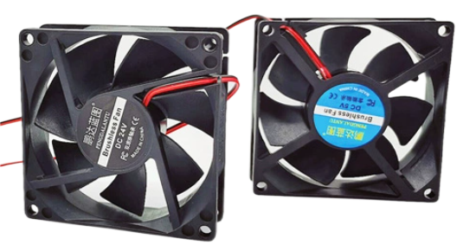
Specification
Rated voltage: DC12V
Rated current: 0.25A
Power consumption: 3.0W
Speed: 3600±10%RPM
Bearing: Oil bearing - double ball bearing
Airflow: 45CFM
Air Pressure: 0.24 Inches
Noise level: 36DBA
Life Expectancy: Constant temperature 40℃ Humidity 5%~95% 25000hrs 50000hrs
Net Weight: 59.1 grams
Dimension: 80*80*25MM
Operating Temperature/Humidity Range: Oil Contained -10~60℃ Humidity 5%~95%RH
Roller Ball -10~80℃
Installation Diameter: Hole Diameter: 4MM Fan Middle Circle Size: 34MM
Wiring instructions: red line positive, black line negative
Maximum diagonal diameter: 111MM
Diagonal Hole Distance: 101MM

Dimensional drawings
