MAKER-REFLECT
Analog Reflectance Sensor (Line Detector)

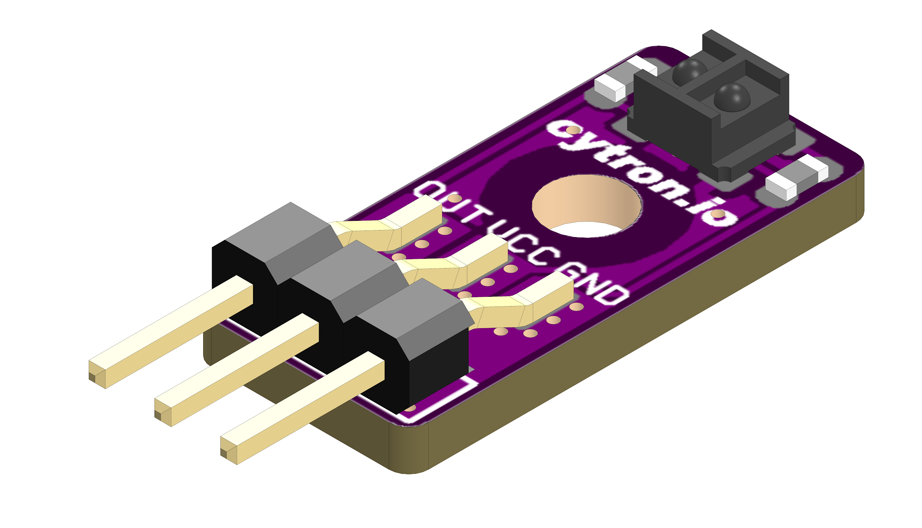

Datasheet

Rev 1.0
November 2019

Information in this publication regarding device applications and the like is intended through suggestion only and may be superseded by updates. It is your responsibility to ensure that your application meets with your specifications. No representation or warranty is given and no liability is assumed by Cytron Technologies Incorporated with respect to the accuracy or use of such information or infringement of patents or other intellectual property rights arising from such use or otherwise. Use of Cytron Technologies’s products as critical components in life support system is not authorized except with express written approval by Cytron Technologies. No licenses are conveyed, implicitly or otherwise, under any intellectual property rights.

1. BOARD LAYOUT & FUNCTION
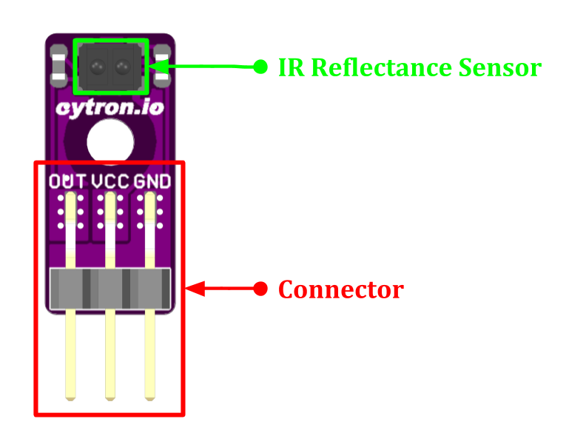
Figure 1: MAKER-REFLECT Board Functions

Function | Description
IR Reflectance Sensor | Infrared sensors for line detection.
Connector | Connector:  - VCC : Power input for the Maker Reflect.*  - GND : Ground.*  - OUT : Analog output. Higher voltage = darker surface.  * Warning: Reversed Polarity will damage the sensor.
Table 1: MAKER-REFLECT Board Functions

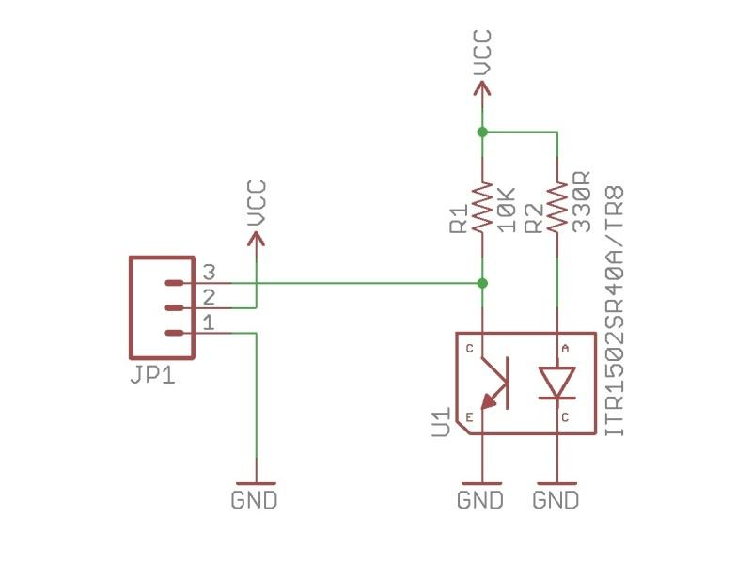
Figure 2: MAKER-REFLECT Schematic

2. SPECIFICATIONS

No | Parameters |  | Min | Max | Unit
1 | VCC Voltage |  | 3.0 | 5.5 | V
3 | Analog Output Voltage |  | 0 | VCC | V
4 | Sensing Distance*  (VCC = 5V, Black line on white surface) |  | 1 | 40 | mm
Table 2: MAKER-REFLECT Absolute Maximum Ratings

* Sensing distance may reduce if VCC is less than 5V or the line-background contrast is low.

3. DIMENSION
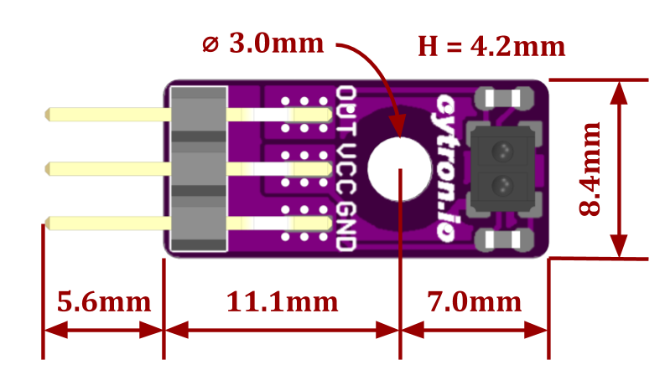
Figure 3: MAKER-REFLECT Dimension

Prepared by:

Cytron Technologies Sdn Bhd
www.cytron.io
No. 1, Lorong Industri Impian 1,
Taman Industri Impian,
14000 Bukit Mertajam,
Penang, Malaysia.

Tel: +604 - 548 0668
Fax: +604 - 548 0669

Email:
support@cytron.io
sales@cytron.io

