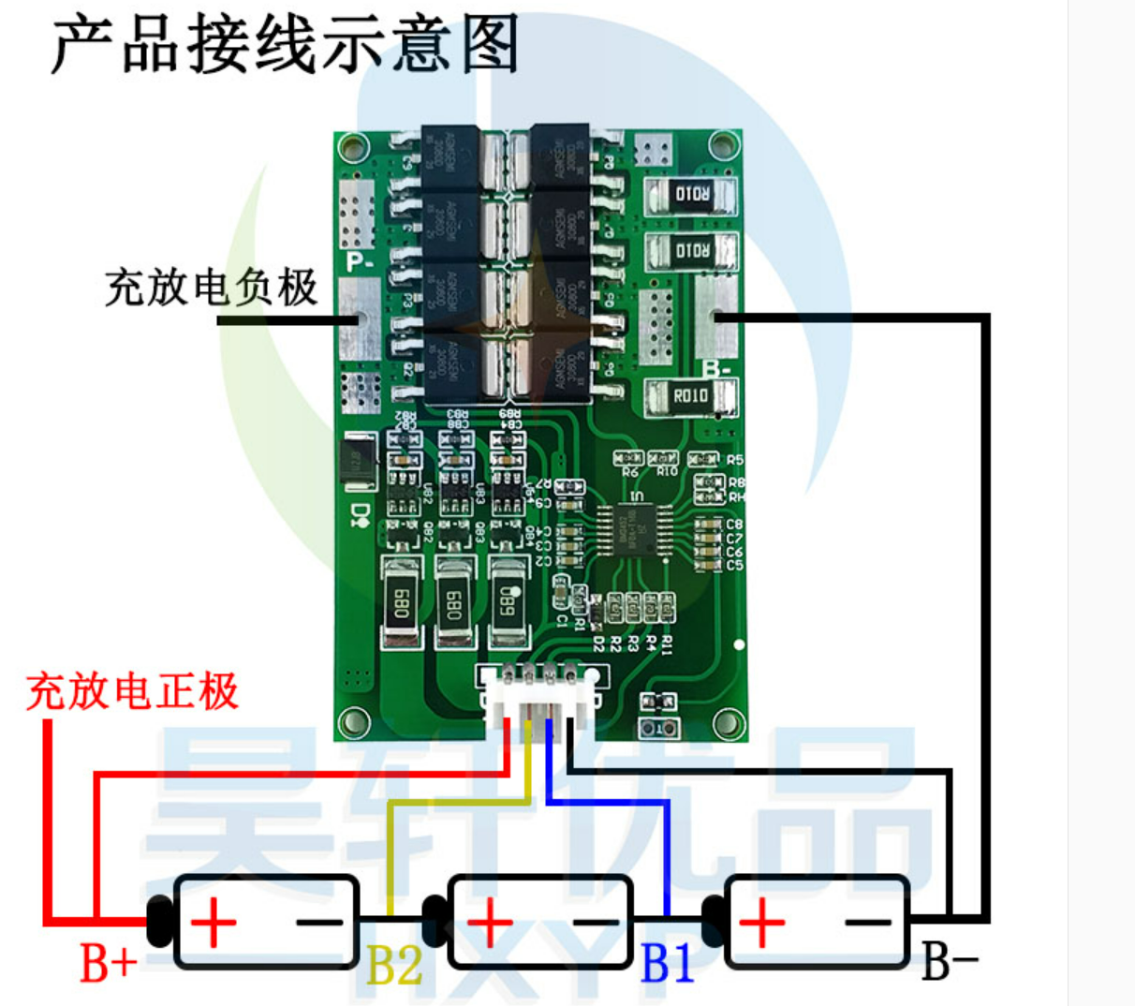
Charge and discharge positive electrode
Charge and discharge negative electrode

