IDC-681H 25MW 40CH VTX 600TVL M7 FPV Camera

Specifications:

1 . Frequency: 5.8G Channel: 40CH (5 frequency bands, 8 frequency points) Bands: A, b, C, d, E, F, Channel: 1,2,3,4,5,6,7,8 .

2. Transmitting power: 25mW.

3. Working voltage: 3V-5.5V

4. Working current: 230mA/5V.

5. Resolution: 600TVL M7 lens

6. Lens wide angle: 120° FOV 150° DFOV

7. Image format: PAL/NTSC adjustable

8. Size: 12*15*9.5mm.

Operating instructions:

1. Channel control:

(1) Operation method: the default frequency is b2 when power-on, short press the button to adjust channel 1-8; long press the button for 2s, the P/N indicator flashes and release, then short press the button to adjust bandsA-E; no operation After pressing the key for 5 seconds, it will automatically save and exit.



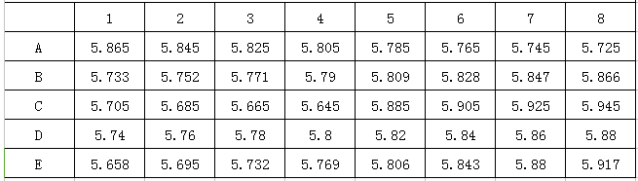

(2) Keep pressing the button 5S to switch between PAL/NTSC system, and switch to the set system after power on again.

(3) The channel has a memory function to save the parameters when the power is off.

NEW 5.8G 48CH 25mW VTX 1200TVL D25 FPV Camera PAL / NTSC Switchable For RC FPV Micro Mini Frame Kit Quadcopter Part
